Refreshing Token for an Existing Site
If the site already exists, jump to SharePoint API Permissions

Create a New Site

Step 1 - Start Creation - Method 1
- Go to the main SpecterX organization SharePoint (https://specterx.sharepoint.com/)
- Login with aip_svc@specterx.onmicrosoft.com
- Looking for the ‘Create site’ button on the top-right of the SharePoint site.

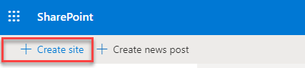

Step 1 - Start Creation - Method 2
If the ‘Create site’ and ‘Create news post’ button don’t appear, try the following:
- Go to https://admin.microsoft.com/AdminPortal/
  - Login with customers tenant aip-service user
- Click ‘Show all’
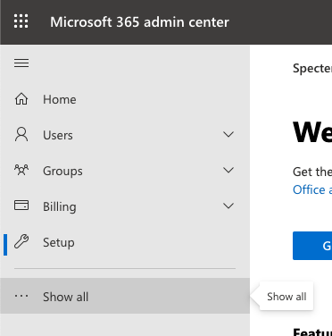
- From the new list that opened, click ‘SharePoint’
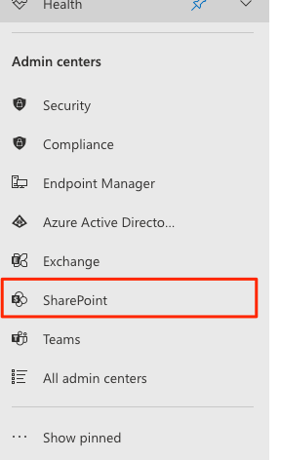
- On the left-side menu, click ‘Sites’ and then ‘Active sites’
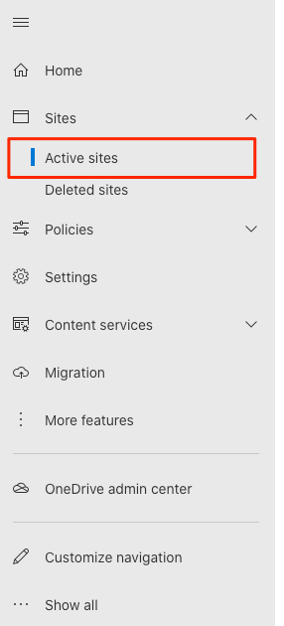
- On the new page the loaded, below the big ‘Active sites’ title, find and click the ‘Create’ option
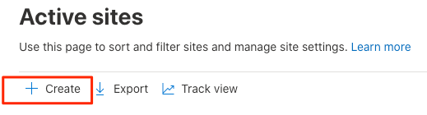

Step 2 - Configure Created Site
- Select “Team site”
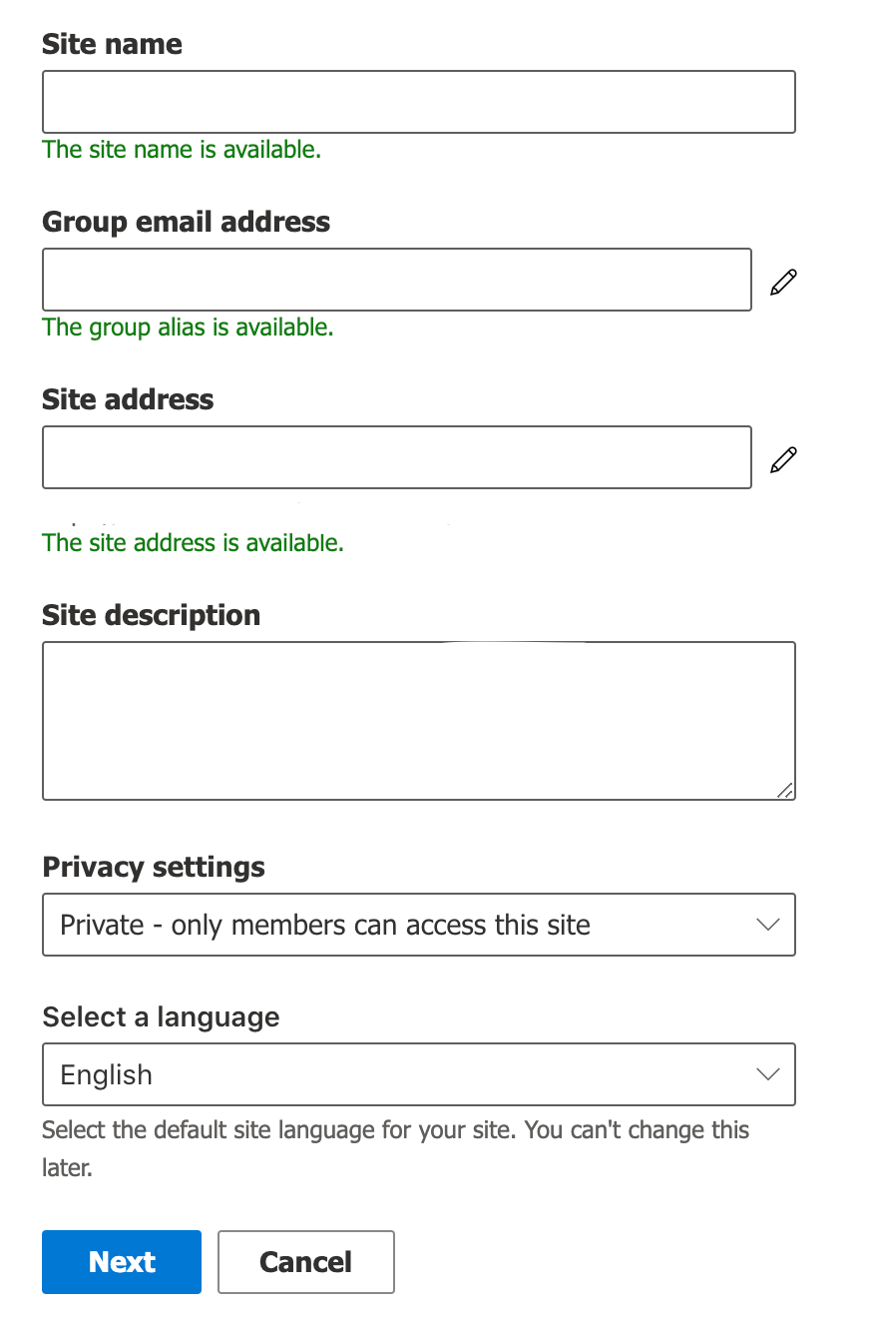
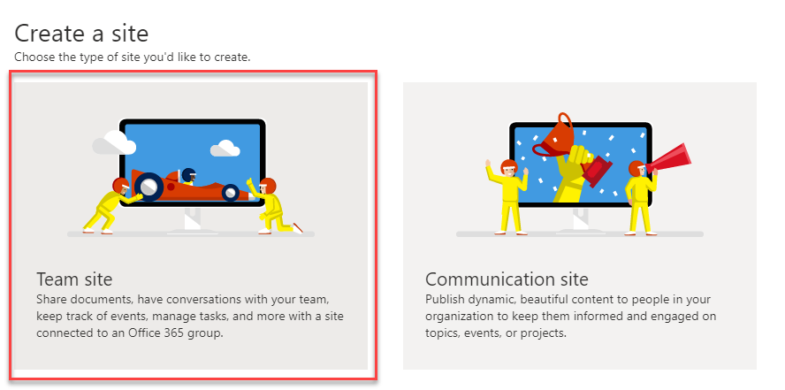
- Setup the site using those parameters:
  - Site name: “SecureDocs-{customer_name}”
(no spaces). Examples:
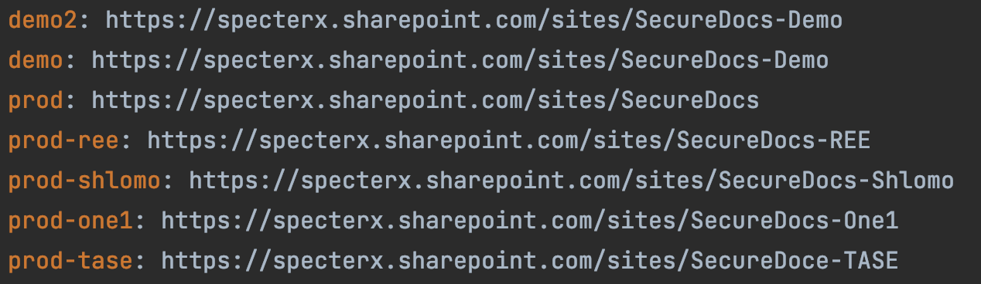
  - Site description:
“Temporarily holds customer files while they are opened in Office365”
  - Site address: “SecureDocs-{customer_name}”
(same as site name)
  - Privacy settings: “Private”
  - Language: English

- Click “Next”
- If a “Who do you want to add?” step is shown, just click “Finish”. You can change this setting later.
- Congratulations, the site is now successfully created!
- Copy the url from the browser’s address bar and save it as ‘Site URL’.
It should be something like: specterx.sharepoint.com/sites/SecureDocs-CustomerName
You will use this Site URL in the next steps as a baseline for other pages you’ll visit.
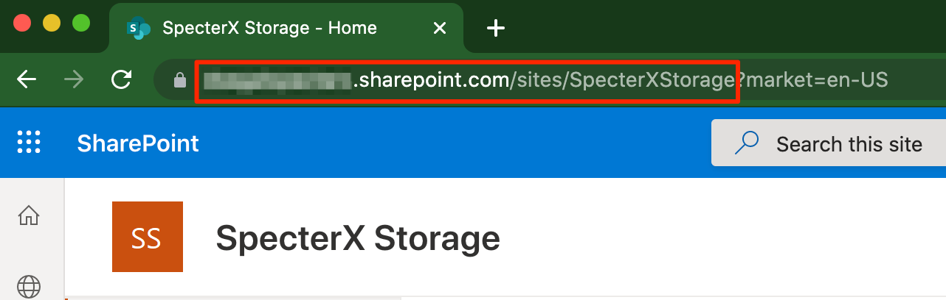

In the next segment we’ll give the SpecterX platform permissions to save files to this site.

SharePoint API Permissions

Register Add-In using the AppRegNew form
- Navigate to - [Site URL]/_layouts/15/AppRegNew.aspx
- Click on “Generate” for “Client Id” and “Client Secret”. Save the generated values together with the Site URL from before.
- Fill in the reset with those params:
  - Title: SpecterX Secure Docs
  - App Domain: www.specterx.com
  - Redirect URI: https://www.specterx.com
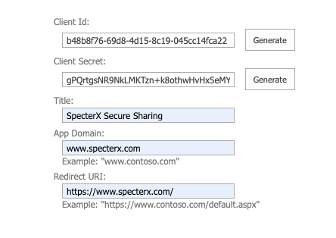
- If you didn’t copy the Client ID and Client Secret on the previous step, you can copy them now. Notice: Past this point you won’t be able to recover the Client Secret.
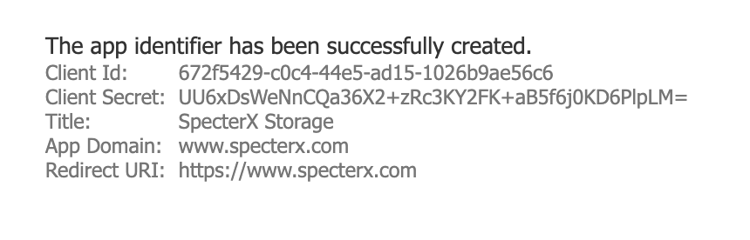

Grant permissions to the add-in
- Navigate to [Site URL]/_layouts/15/AppInv.aspx
- In the “App Id” field insert the client Id from the previous step and click on “Lookup”
- On the Permissions Request XML insert this and click “Create”

<AppPermissionRequests AllowAppOnlyPolicy="true">
<AppPermissionRequest
Scope="http://sharepoint/content/sitecollection/web"
Right="FullControl" />
</AppPermissionRequests>

This provides access to files on SharePoint sites
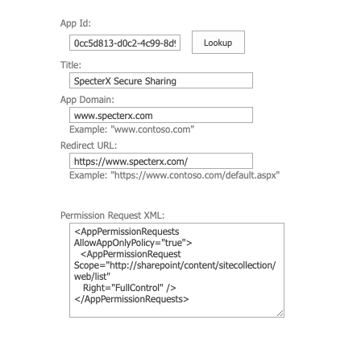
- On the next screen click on “Trust It”
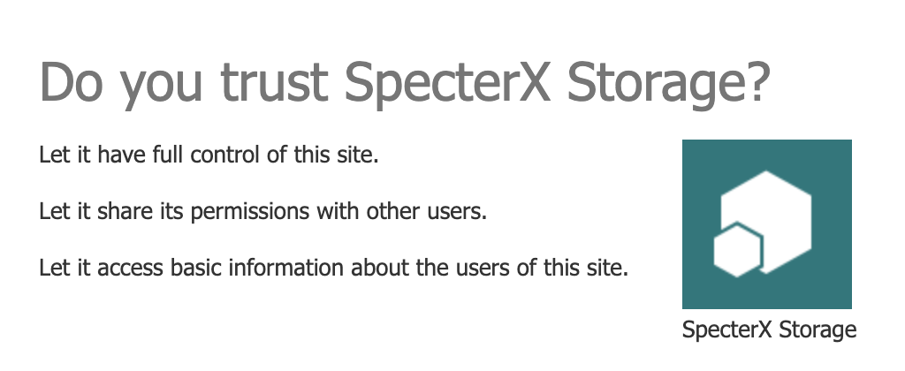

Disable Offline Sync
- Navigate to [Site URL]/_layouts/15/srchvis.aspx
- Change the following settings:
  - “Allow this site to appear in search results?” - Set to “No”
  - “Allow items from this site to be downloaded to offline clients” - Set to “No”

Find the ‘Realm ID’ value
- Navigate to [Site URL]/_layouts/15/AppPrincipals.aspx
This is the Site Collection App Permissions page.
- Identify the row with your registered application and locate it at the App Identifier column. Site Realm ID corresponds to the part of App Identifier followed after the last @ delimiter.

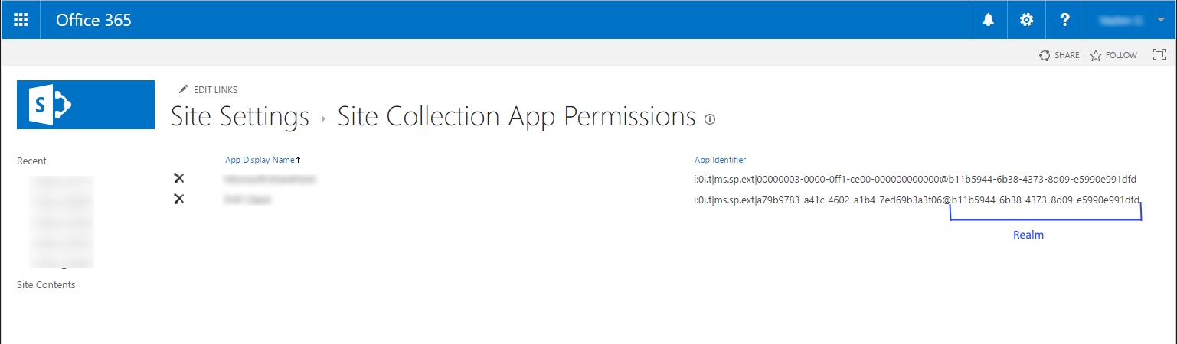

- Copy this part and save it as Realm ID together with the Client ID, Client Secret and Site URL.

Check That the Client Secret Works
- Open a command line tool and use the following command (fill in with the newly created values):
curl -XPOST -H "Content-Type: application/x-www-form-urlencoded" -d "grant_type=client_credentials&client_id=CLIENT_ID@REALM&client_secret=CLIENT_SECRET&resource=00000003-0000-0ff1-ce00-000000000000/specterx.sharepoint.com@REALM" https://accounts.accesscontrol.windows.net/REALM/tokens/OAuth/2

Save the Values in Config Files

Update lib repos
- Fetch the latest ‘cloud_apps’ repo changes on the ‘staging’ branch
- Under cloud_apps/sharepoint_accounts_creds create a new file called sharepoint-mediation-site-{tenantName}
(for example: sharepoint-mediation-site-prod-varonis)
- Use the following template and fill-in the details from the previous steps:
{
"site": "https://specterx.sharepoint.com/sites/SecureDocs-xxxx",
"client_id": "xxxx",
"client_secret": "xxxx",
"realm": "c85bd9bd-b145-4af6-8290-21df9fddf3f3"
}

Update SystemConfig.yml
- Fetch the latest ‘configurations’ repo changes on the ‘master’ branch
- Add the following values:
  - aip_logs_tenant_id (value: realm)
  - sharepoint_mediation_site_url (value: site)
  - sharepoint_mediation_client_id (value: client_id)
  - sharepoint_mediation_client_secret (value: client_secret)
  - sharepoint_mediation_realm (value: realm)
  - azure_sharepoint_app_tenant_id (value: realm)
- Deploy the Configrations repo to update the SSM values with these new SystemConfig values.
- When the Configrations build is done, Deploy access-service to fetch the new values from SSM.

Make sure it works
Upload a DOCX file to the platform and open it with Office365

FLAGSMITH - Enable flag for New App Auth

